Nickel Phosphorous Electroless Plating

Chris Guarino Living Notes

Operations Procedure

General 3 Stage Process

1. Remove oxide growth with Sulfuric Acid (H2SO4) Bath.
2. Coat wafer surface in Palladium Sulfate, PdSO4(Catalyst).
3. Plate wafer with Nickel Phosphorous, Ni(P).

* Rinse wafer before and after each step.

Chemistries

**Nickel Phosphorous (Ni(P)) Solution**

Concentrations: For a 2.5L batch

*Combine in this order.

* DI Water = 76.5% = 1,912.5ml
* Ephithas ANPM = 20.0% = 500ml
* Ephithas ANPN = 3.4% = 85ml
* Ephithas ANP Brightener = 0.1% = 2.5ml

**5% H2SO4**

Concentrations: For a 3.5L batch

*Combine in this order and method.

* Place 2L of DI Water in a 4L beaker.
* Slowly add 183ml of 96% H2SO4.
* Now add enough DI Water to the 3.5L mark.

**0.1g/L PdSO4**

Concentrations: For a 1.5L batch

*Combine in this order and method.

* Place 1.5L of 5% H2SO4 into container.
* Add 0.15g PdSO4, Analytical reagent grade.
  + Allow to stir for two days to ensure that PdSO4 fully dissolves, add more H2SO4 if solution level drops below 1.5L.

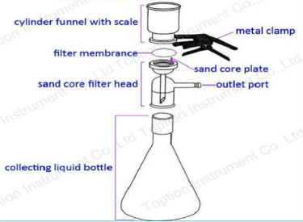

CATCH BASIN

*Note: for FRESH solutions, use 0.2um filter initially then follow with 0.05um filter

for USED solutions, only filter with 0.05um.

Plating Preparation

Note: Preparation should be done a day before plating.

1. Rinse the Jacketed Beaker 3X.
   1. Fill with DI water while running stir paddle and drain.
2. Fill Jacketed Beaker with Nickel Phosphorous solution.
   1. IMPORANT: This needs to be pumped in with the in-line filter (0.1um).
      1. This is necessary because the Ni(P) solution is an active chemistry. Plating occurs in solution naturally without a catalyst. Consequently, particles of any kind can mask plating on the surface of the wafer.
      2. First run water through the line. Both to ensure that it is operating properly and to make sure there are no leaks.
      3. The in-line filter can only be used TWICE. If it is used beyond that pressure will build in the housing and burst open.
      4. Keep in mind that the filter can only be used in one direction (Arrow on filter housing).
      5. Pay attention to kinks and try to keep the filter as up-right as possible as to use as much surface area of the filter as possible.
3. Measure the pH of the Ni(P) before plating.
   1. pH is measured and adjusted at room temperature.
   2. pH should read around 4.
      1. Lower pH: Slower plating rate ; Higher pH: Faster plating rate
4. The morning of plating turn on the stir paddle and the heater.
   1. Bath needs to be around 85 degrees Celsius.
      1. Lower Temp: Slower plating rate ; Higher Temp: Faster plating rate

MT Monitor Plating Rate Qualifying Process

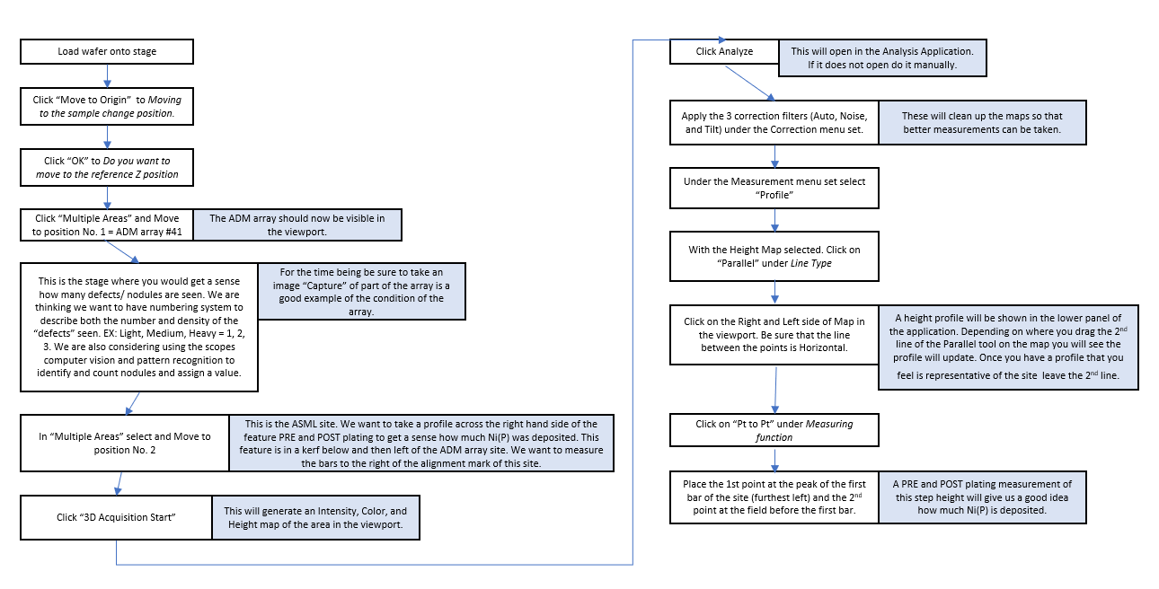

Operations Procedure

Note: Move ON DI water hose from tank to take with the processing wafer. To keep a constant flow of DI water in the tank.

1. Rinse wafer in the 1st DI water tank (~30 seconds).
2. Bath wafer in H2SO4 for 3 minutes.
   1. This will remove any oxide growth on Cu interconnects.
3. Rinse wafer in the 2nd DI water tank for 1 minute.
4. Bath wafer in PdSO4 tank for 2 minutes.
   1. This acts as a catalyst to initialize a reaction on the Cu interconnects.
   2. Rotate the wafer by moving the wafer holder handle from one side of the tank to the other after every minute.
      1. This will help to avoid any “micro air bubbles” from masking out parts of the wafer to being coated.
5. Dip wafer in the 3rd DI water tank for 1 minute.
   1. This is intended to be a quick rinse to shed any excess PdSO4.
   2. A longer rinse could wash away to much PdSO4.
6. Transfer wafer to dedicated wafer holder for Ni(P).
7. Set a timer and lower wafer into the Ni(P) solution.
   1. Time is variable as this is electroless plating (Time based on Plating Rate Qual).
8. Remove wafer from Ni(P) tank and rinse for 2 minutes in the 4th DI water tank.
9. Dry wafer in Spin Dryer.

Filtering Solutions

Ni(P) – Nickel Phosphorus

IMPORTANT: This solution should be filtered before each use. The chemistry is very active and due to the electroless nature of the process a small about of Ni is plating in solution. These floating scraps of Ni can mask out the intended plating area on the surface of a wafer during processing. In fact any particles in the solution can result in this.

1. Measure the pH of the solution.
   1. This is done before every use of the solution. To ensure and monitor the quality and potential degradation of the bath.
   2. Be sure to calibrate the probe beforehand with both the 4pH and 7pH standards.
2. Lower the pH probe into the solution at room temperature and while the stirrer homogenizes.
3. You will hear a beep when the pH reader stabilizes on a pH.
4. Set up the parasitic pump on the counter aside the jacketed beaker.
5. We use an inline filter between tubing with the parasitic pump.
6. Pump DI water into the filter to rinse it out (1 minute).
7. Place the inlet end of the tubing into the NiP solution.
   1. Be sure that the filter is up right. This will ensure that the full surface area of the filter is being used.
8. Once done pumping solution rinse the filter and tubing with DI water (1 minute).

OLD Processes: Step Height Rate Check

DUMMY

1. Once the Dummy has been plated remove the red plater’s tape from the center of the wafer piece.
2. We want to measure the step height of the masked area.
   1. This is done on the profilometer tool. Currently using the P-11 in 1-150.
3. Center the dummy on the profilometer chuck.
   1. Orient the rectangularly masked area vertically.
4. Engage the vacuum.
   1. Toggle switch on the front of tool.
5. On screen select “MAN LOAD”.
   1. This will move the chuck into position.
6. Select “FOCUS”.
   1. This may take a moment.
7. Once focused ensure you have the correct recipe selected.
   1. “NIP-DUM”
8. To change recipe select “Cancel” – “RECIPE” – “Recipe” – “Open” – “NIP-DUM” – “OK”
   1. Correct recipe is now loaded.
9. Select the “XY View” icon.
   1. Ready to measure.
10. Measure across the Top, Center, and Bottom of the masked area.
    1. For each site you want to have two data points.
       1. Left and right step differentials.

M2 Monitor

1. We want to measure the before and after plating step heights for the M2 FTA 3 Cu pads.
   1. This should give us a good idea as to how much Ni has been plated over the Cu.
2. Place the wafer on the profilometer chuck.
   1. Orient the wafer NOTCH LEFT.
3. Engage the vacuum.
   1. Toggle switch on the front of tool.
4. On screen select “MAN LOAD”.
   1. This will move the chuck into position.
5. Select “FOCUS”.
   1. This may take a moment.
6. Once focused ensure you have the correct recipe selected.
   1. “CJ2D”
7. To change recipe select “Cancel” – “RECIPE” – “Recipe” – “Open” – “CJ2D” – “OK”
   1. Correct recipe is now loaded.
8. Select the “XY View” icon.
   1. Ready to measure.
9. Pre and Post measurement site coordinates:

|  |  |  |
| --- | --- | --- |
| Site | X | Y |
| Center | -1279 | -1895 |
| Mid | -802 | +37004 |
| Edge | -314 | +75905 |

* + Use the two pads on the right and left sides of the FTA 3 site as the field.

1. Once you have a Pre and Post set of data points you can calculate the amount of Ni plated.